### Chapter-1

#### **KEERTHI SWEETS**

#### **Introduction:-**

#### One can get a beautiful scene of colourful sweets in any Indian sweet shop. Sweets are a symbol of good gesture in India. Hence, sweets are first tasted when any new thing happens or if important decisions are taken. In most countries, sweets are the last course of a meal. In India, though they are served with the rest of the meal and in some traditions especially during celebrations, people start eating a meal only after having had a bite of the sweet on the plate, to signify the celebration.

When it comes to Indian Cuisine and food one thing cannot be overlooked…Our love for Sweets! Most Indians have a sweet tooth or a mouthful of them, to say the least. It’s not uncommon to see huge crowds at Sweet stores across the Country. And with the variety and a sheer number of sweets available it’s no wonder that it’s such an important part of an Indian’s lives. Sweets are part of any Indian celebration or festivity of any kind.

PURPOSE OF KEERTHI SWEETS

* It is difficult not to fall in love with the sweets like rasmalai, kalakand, ladoo, and more.
* No, right. Well, sweets are loved worldwide for their mouthwatering flavors and tas. But besides the zest, there are numerous benefits of eating sweets.
* But sweets are better alternatives when you are feeling too low. Surprised? BuWith no glucose, you will not have the required energy to perform day-to-day activities. So on the low and depressing days when you want to It is not a shocker that sweets always make us happier.
* It is not a shocker that sweets always make us happier. It is because whenever someone consumes any sweet, it activates a dopamine hormone which is responsible for enhancing the mood
* It is not a shocker that sweets always make us happier. It is because whenever someone consumes any sweet, it activates a dopamine hormone which is responsible for enhancing the mood
* Naturally, the sweetened product can assist you in enhancing your thinking capabilities.
* Many sweets include natural flavors with antioxidants that improve the cognitive ability of a person.
* There is a specific reason for which our body craves some delicious sweets. People on a low carbohydrate diet often ignore the fact that glucose is also a significant nutrient of the

CHAPTER-2

Problem Definition And Design Thinking

Empathy Map:

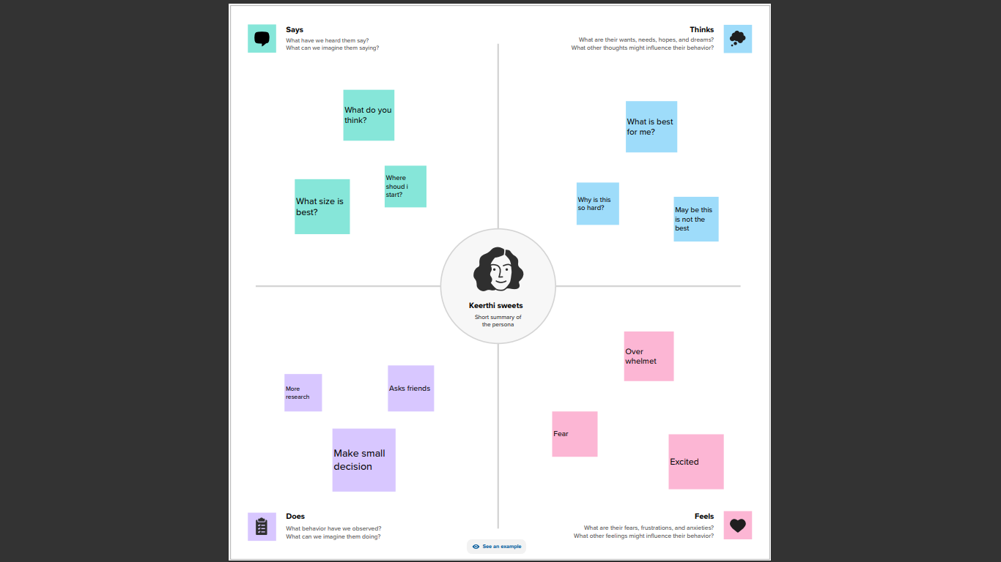

BRAINSTROMING:

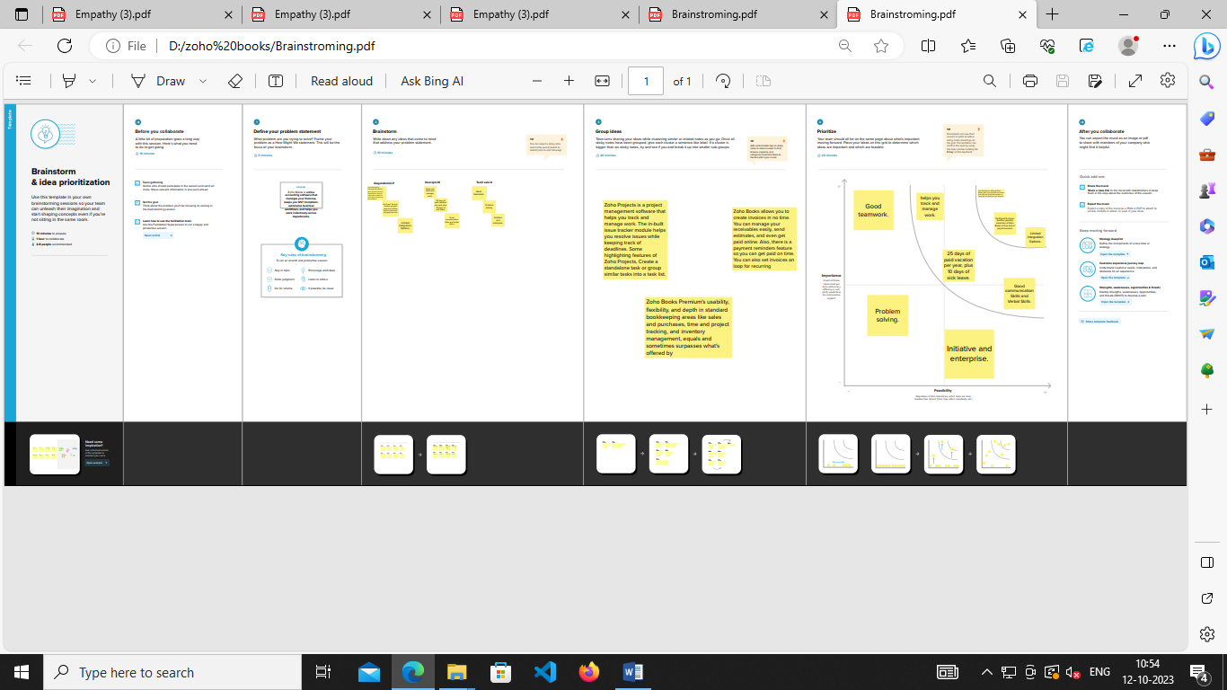

CHAPTER-3

RESULT

Profit And Loss Account

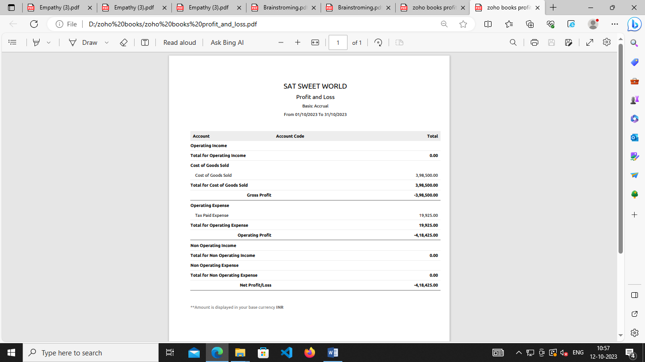

BALANCE SHEET

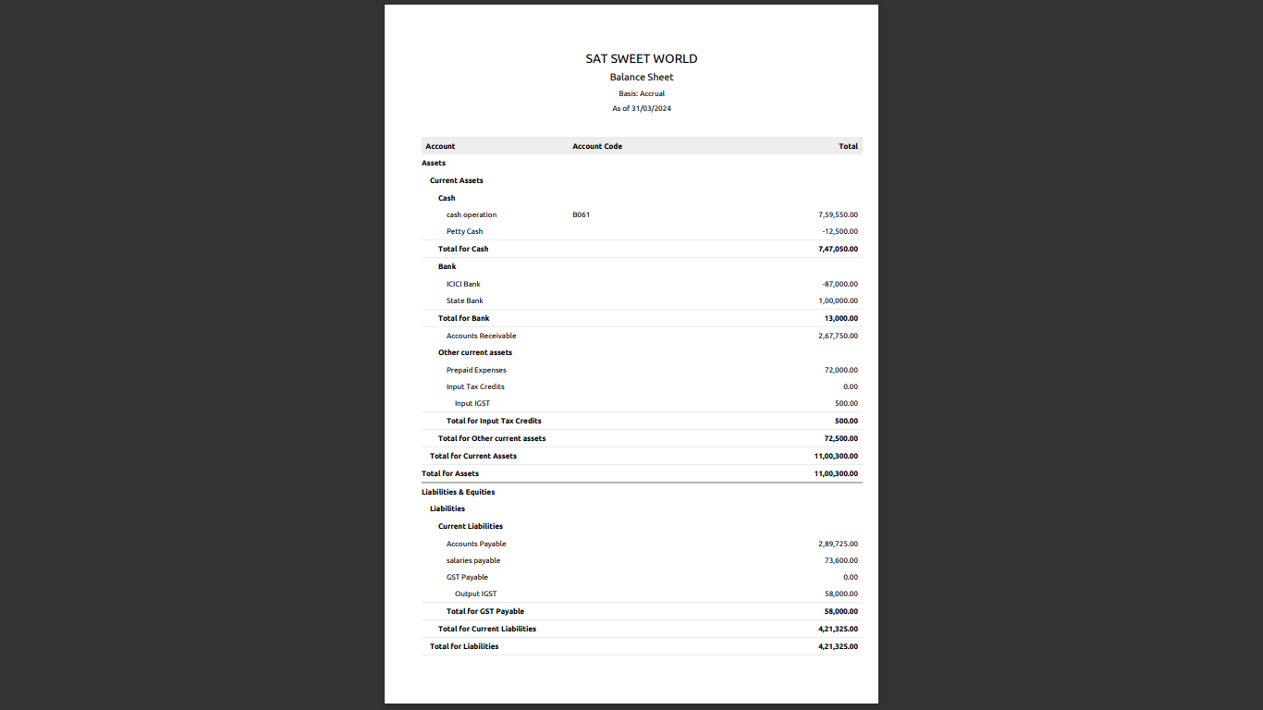

CHAPTER-4

Advantages of Sweets

* Natural dark chocolate, for example, is abundant in antioxidants and cocoa flavanols, so every bite of this dark chocolate provides health benefits.
* According to research, cocoa flavanols can improve cognitive function, increase thinking skills, protect brain cells from damage, and aid in the formation of neural connections.

* For people who like sweets, when eating them, the pleasure area of ​​their brain gets activated and makes them happy.
* Sweets contain glucose molecules (the body’s major source of energy) which help to keep us functioning
* The right amount of sugar can help to power both your mind and body. But too much sugar consumption daily may deplete the human body’s glucose and energy stores.

**Disadvantage of Sweets**

* Everyone enjoys sweet foods; yet, eating sweet dishes does not rapidly satisfy one’s hunger, leading to an increase in the desire to consume more and obesity
* Good cholesterol keeps the body healthy whereas bad cholesterol harms health.
* It has shown that sweet or sugary foods elevate bad cholesterol quickly in the body and increase the risk of heart disease.
* Eating sweet foods raises the risk of diabetes, because sweet foods raise glucose levels, preventing the body from producing insulin.
* As a result, hunger is sensed, and the loss of appetite persists. It may make you more susceptible to diabetes.

Top of Form

CHAPTER-5

Application

At Sweet Solutions, we believe in the limitless potential of food. Our passion for innovation drives us to push the boundaries of what's possible and create truly unique and delicious products. With years of experience and expertise in product development, manufacturing, and ingredient sourcing, we are dedicated to helping our clients turn their vision into a reality.

Whether you're looking to create a new product, improve an existing one, or simply want to explore what's possible, our team of experts is here to help. We work closely with our clients to understand their needs and help them overcome any challenges they face, ensuring a smooth and successful journey from start to finish.

A sweet solution, such as sucrose or glucose, can be used for analgesia for minor short term procedural pain, such as immunisation, in infants up to 12 months of age. The sweet solution is given orally and provides short term analgesia. It has National Health and Medical Research Council (NHMRC) Level I evidence of efficacy and no serious adverse effects have been reported. This article is part of a series on non drug treatments summarising indications, considerations, evidence and where clinicians and patients can get further information.

Mammals’ first tasting experience is usually sweet solution. Whether it is milk (breast or formula), sugar water as in some cultures or even dates as advocated by Prophet Mohammed to his followers. Thus, it is no wonder the soothing, calming and even pain relieving effects of oral sweet solutions. Nevertheless, using sweet solution purposely for its pain-relieving effects for infants in the clinical setting is relatively recent; however, the discussion concerning sweet solution effectiveness, mechanism of actions and adverse long-term effects are still ongoing. In this chapter, we present an account of studies on both humans and animals that explored and examined the use of several sweet solutions for analgesia.

The implementation of sweet solution for minor painful and invasive procedures in the NICU has been documented in many studies and extensive review of studies showed that sweet solutions have analgesic effects in young children up to one-year-old [[16](https://www.intechopen.com/chapters/53119#B16)].

CHAPTER-6

Conclusion of sweet

jen Harrington is the owner and pastry chef of Sweet Conclusion, a bakery in Tampa, Florida. Most of Harrington's business comes from baking wedding cakes, but she has been attempting to attract customers to her retail bakery, where she sells cupcakes, pies, ice cream, and coffee. Nearly four years she opened Sweet Conclusion, the retail part of her business has not been as successful as she had hoped. Harrington wonders how she can make the other parts of her business more successful. Readers have the opportunity to develop and evaluate strategies for attracting more customers to Harrington's retail bakery.

OUR STYLE: We specialize in no fondant, custom weddings cakes. Our covering is made of our blend of delicious chocolate marshmallow blend. We only use ‘Grandma’s/American style’ cake and buttercream made from scratch. Whipped cream base. Filling is included for cakes, cupcakes add .50 cents each. All of our cakes are 4 layers high, except sheet cakes are 2 layers high. We allow one flavor per cake tier; or, per dozen, for cupcakes, cake pops, and decorated cookies. Cupcakes, cake pops, decorated cookies are available with a minimum of 1 dozen each. Create your wedding cake with the help of our baker’s artistry skills.

CHAPTER-7

FUTURE SCOPE OF SWEETS

Our report on the Global Sweet Sauces Market provides a comprehensive analysis of the key trends, opportunities, and drivers influencing the growth of the market. This report offers an in-depth assessment of the current competitive landscape, growth prospects, and market dynamics. It also offers strategic insights into the development of the market over the forecast period.

The report includes an assessment of the industry's impact on the global sweet sauces market, along with a comprehensive analysis of the key players in the market. It offers detailed insights into the competitive landscape, including market share and financial performance analysis of the top companies. Additionally, the report provides an overview of the market dynamics, including drivers, restraints, and opportunities, and an analysis of the current and future market size. Furthermore, the report offers a detailed analysis of the regional performance of the market, along with the competitive landscape across key regions. Finally, the report provides a detailed analysis of the market segmentation, including product type, distribution channels, and application, as well as a detailed analysis of the current and expected market trends.

Overall, Sweet Sauces Market research provides businesses with a comprehensive understanding of the Sweet Sauces Market . By analyzing the current market dynamics and future projections, businesses can identify potential opportunities and risks and develop effective strategies to achieve their goals.